3Musketeers

Xiao hui | anita | sanjeven ramaksihanan

Graduate Certificate in Intelligent Reasoning Systems

Covid-19 Event screener installation & user guide

Contents

Requirements 2

Prerequisite 2

Recommended browsers 2

System Overview 2

Deployment 2

User interface 3

Questionnaire 4

FAQ Chatbot 11

# Requirements

## Prerequisite

* Computer with internet access
* Python 3.6 installed

## Recommended browsers

Our screening system supports the following browsers:

* Microsoft Edge version 90 and above
* Google Chrome version 90 and above
* Opera 75 and above

# System Overview

Our Covid-19 event screener application is targeted at event organisers who would be managing crowd at large events. In our current setting in Singapore, event goers who have completed their vaccination do not have to go through the PCR test or any form of tests before entering the venue. However, there are cases where vaccinated personnel have caught the virus after vaccination. As such, our screener is targeted at participants who have completed their vaccination to serve as an extra layer of protection.

Besides providing screening, Our system also has a chatbot which serves as an FAQ bot answering questions related to Covid-19 or the event that is taking place.

# Deployment

Our system is deployed to a windows server. In order to run our system locally, you would need python 3.6 installed along with the following packages. These packages can also be installed via the requirements files provided.

To get started, we can download the source code at <https://github.com/xiaohuihong/IRS-PM-2021-05-01-IS03PT-GRP-3Musketeers-CoviDetector.git> or via the git clone command below:



Navigate to \SystemCode\CovidDectector\webscrape folder. Install the required packages and start webscrapping. The script can be scheduled to run daily using window scheduler for window os or crontab on linux os.

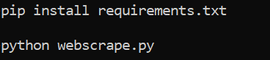

Navigate to the folder \SystemCode\CoviDetector and we will then proceed to install the required packages and start up the server locally with the following commands:



# User interface

Once the server is running, use your preferred browser to visit the link localhost:8000. We would recommend using Google chrome. We have three main sections to our application. Home, FAQ Bot and About.

Landing Page

This is the page users will first see when they access the application. From here, they are able to either start the questionnaire, access the FAQ bot or to read about the application.

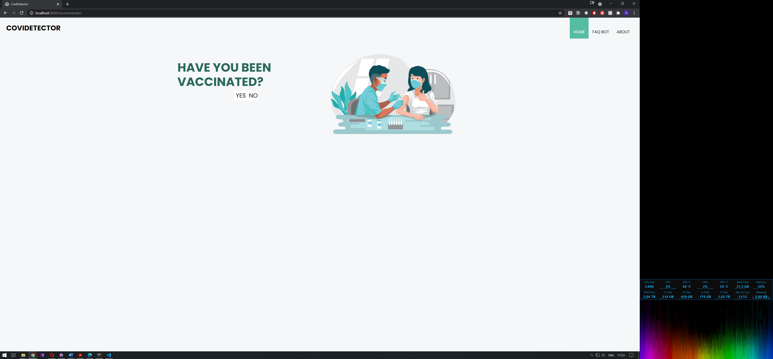

*Image 1: Landing page*

FAQ Bot

Here, users will have access to our FAQ bot and would be able to ask questions regarding Covid-19 or the event taking place.

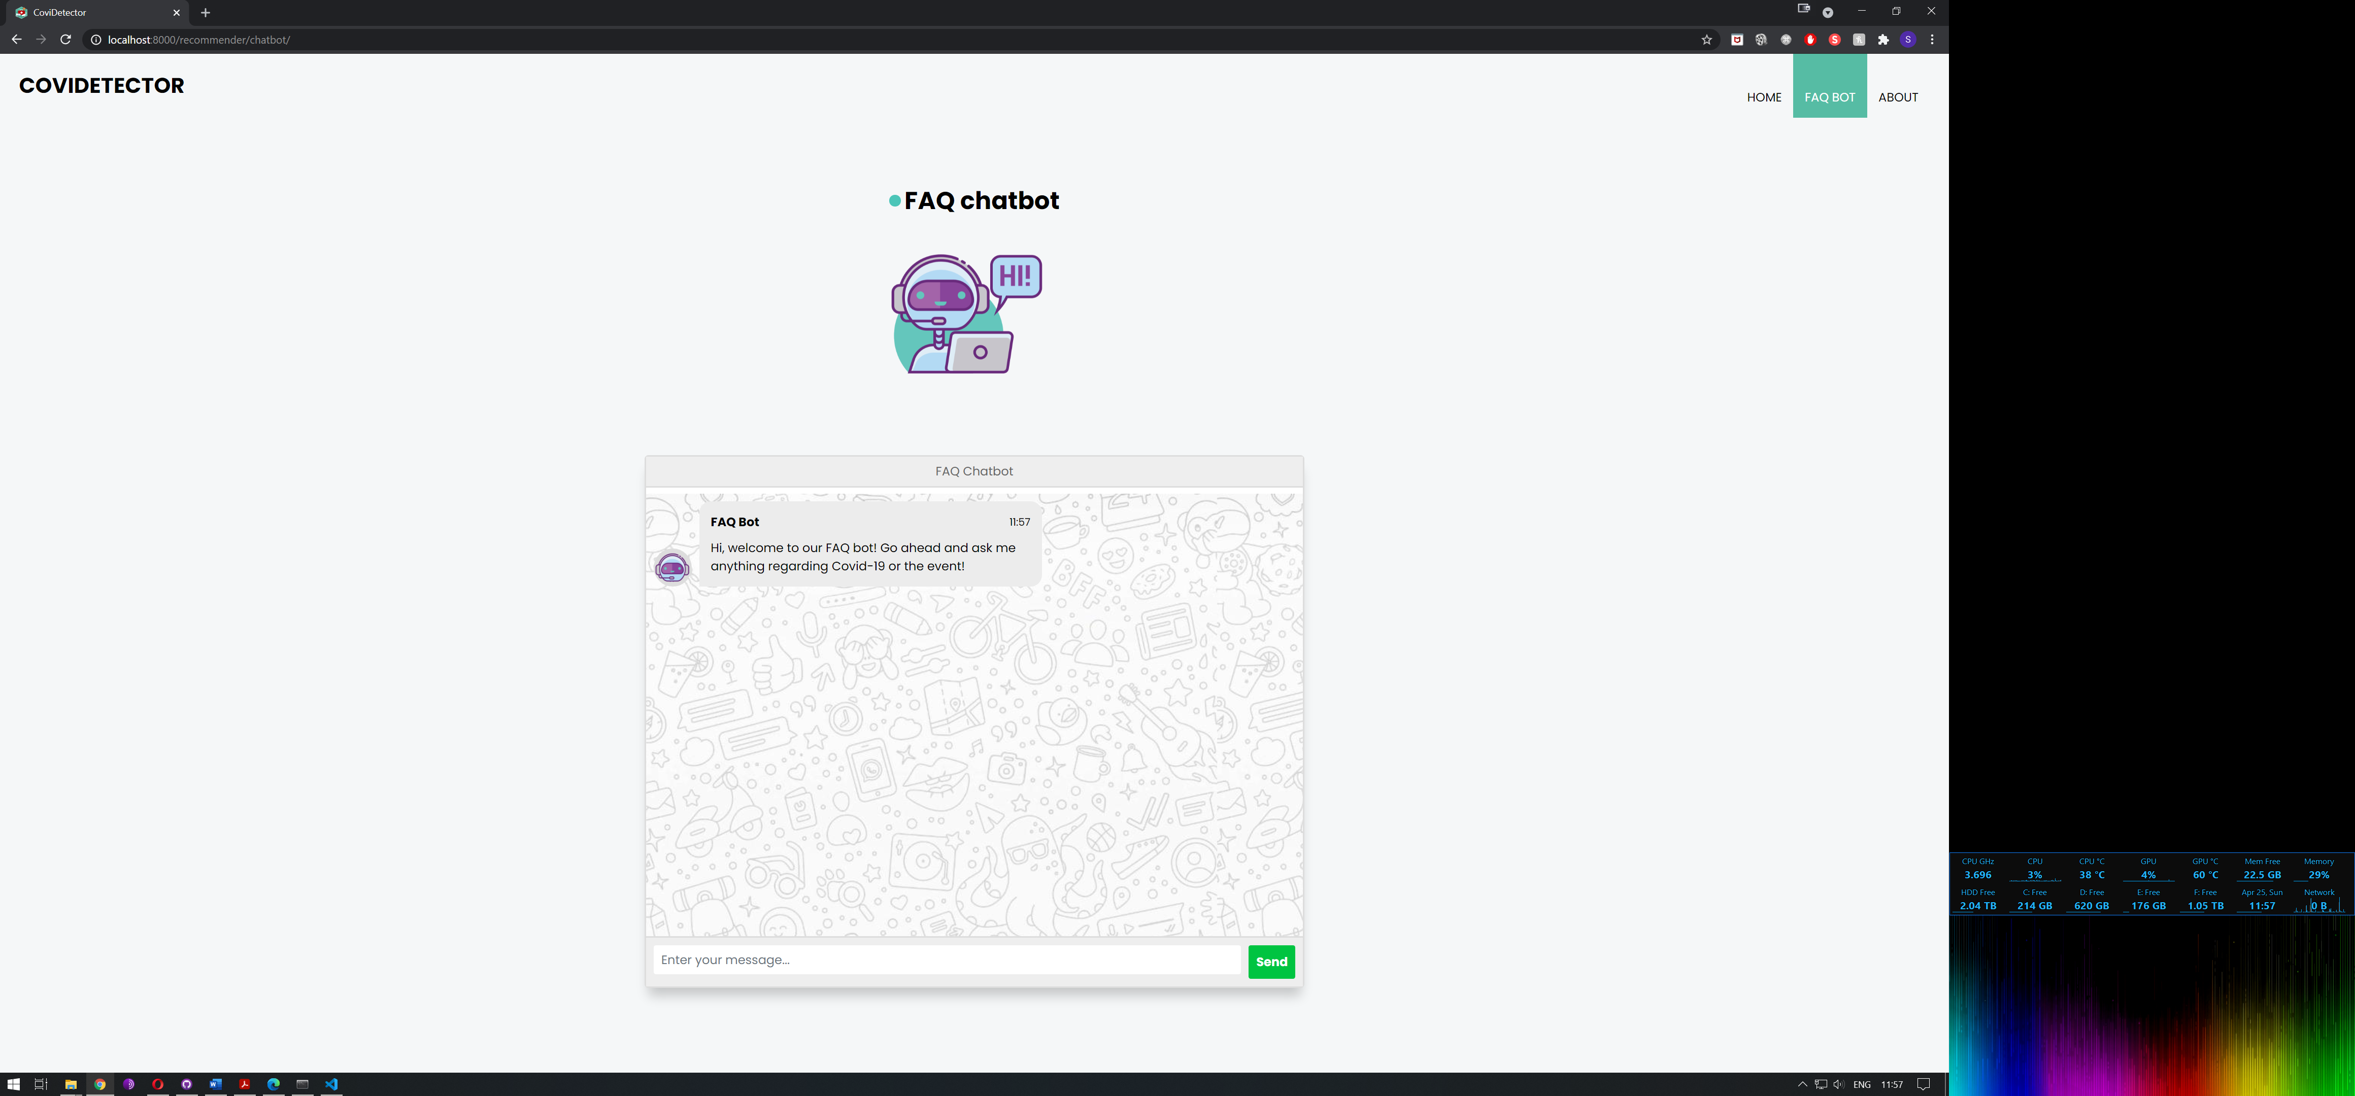

*Image 2: FAQ Bot*

About Page

Users will be able to read more about the project and the developers involved here.

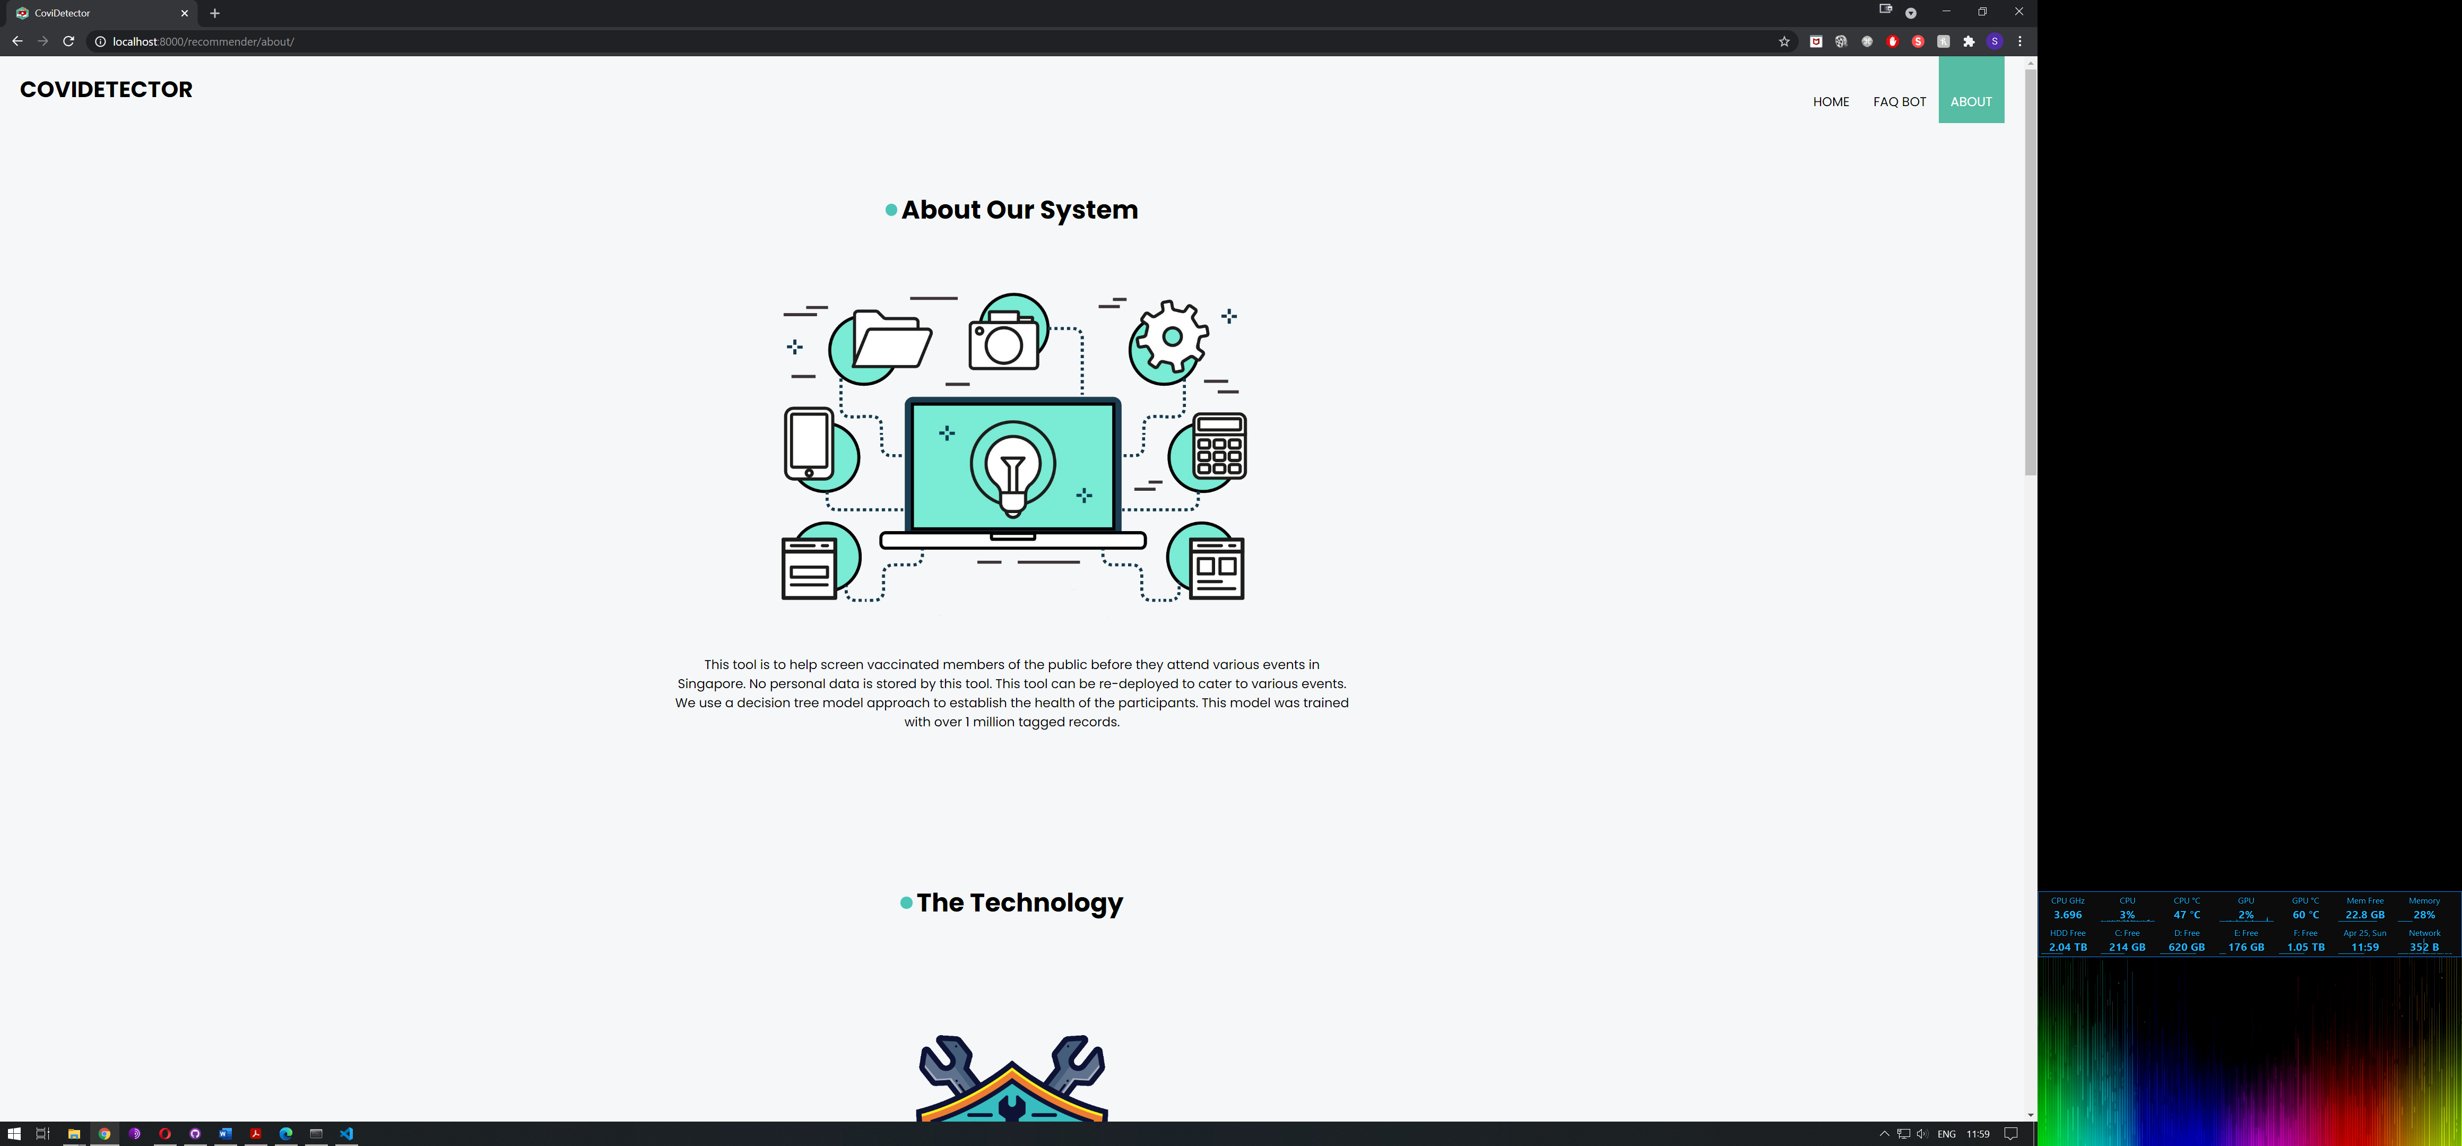

*Image 3: About us*

# Questionnaire

Users will go through the following questions:

1. Have you been vaccinated?
2. What is your age?
3. Have you been overseas in the last 14 days?
4. Have you been in contact with someone with COVID-19?
5. What is your gender?
6. Do you have cough?
7. Are you experiencing breath shortness?
8. Are you running a fever?
9. Do you have a sore throat?
10. Do you have a headache?

|  |  |  |  |
| --- | --- | --- | --- |
| **S/N** | **Question** | **User Interface** | **Possible answers** |
| 1 | Have you been vaccinated? |  | Yes – Proceed with the questionnaire  No – The questionnaire will end as we are targeting vaccinated participants. They will be directed to S/N 11 |
| 2 | What is your age? |  | Yes – Proceed with the questionnaire and response will be collected for processing  No – Proceed with the questionnaire and response will be collected for processing |
|  |  |  |  |
| 3 | Have you been overseas in the last 14 days? |  | Yes – Proceed with the questionnaire and response will be collected for processing  No – Proceed with the questionnaire and response will be collected for processing |
| 4 | Have you been in contact with someone with COVID-19? |  | Yes – Proceed with the questionnaire and response will be collected for processing  No – Proceed with the questionnaire and response will be collected for processing |
|  |  |  |  |
| 5 | What is your gender? |  | Yes – Proceed with the questionnaire and response will be collected for processing  No – Proceed with the questionnaire and response will be collected for processing |
| 6 | Do you have cough? |  | Yes – Proceed with the questionnaire and response will be collected for processing  No – Proceed with the questionnaire and response will be collected for processing |
|  |  |  |  |
| 7 | Are you experiencing breath shortness? |  | Yes – Proceed with the questionnaire and response will be collected for processing  No – Proceed with the questionnaire and response will be collected for processing |
| 8 | Are you running a fever? |  | Yes – Proceed with the questionnaire and response will be collected for processing  No – Proceed with the questionnaire and response will be collected for processing |
|  |  |  |  |
| 9 | Do you have a sore throat? |  |  |
| 10 | Do you have a headache? |  | Yes – Proceed with the questionnaire and response will be collected for processing  No – Proceed with the questionnaire and response will be collected for processing |
|  |  |  |  |
| 11 | Results page |  | The results collected previously will be analysed based on our trained model and displays a results page. |

*Table 1: Depicting the questionnaire flow*

# FAQ Chatbot

The chat bot uses the previously scrapped data to display the latest and relevant information pertaining to Covid-19 and the event. Users will be able to use the chat bot by navigating to the FAQ bot tab in the top right and key in their questions in the space provided.

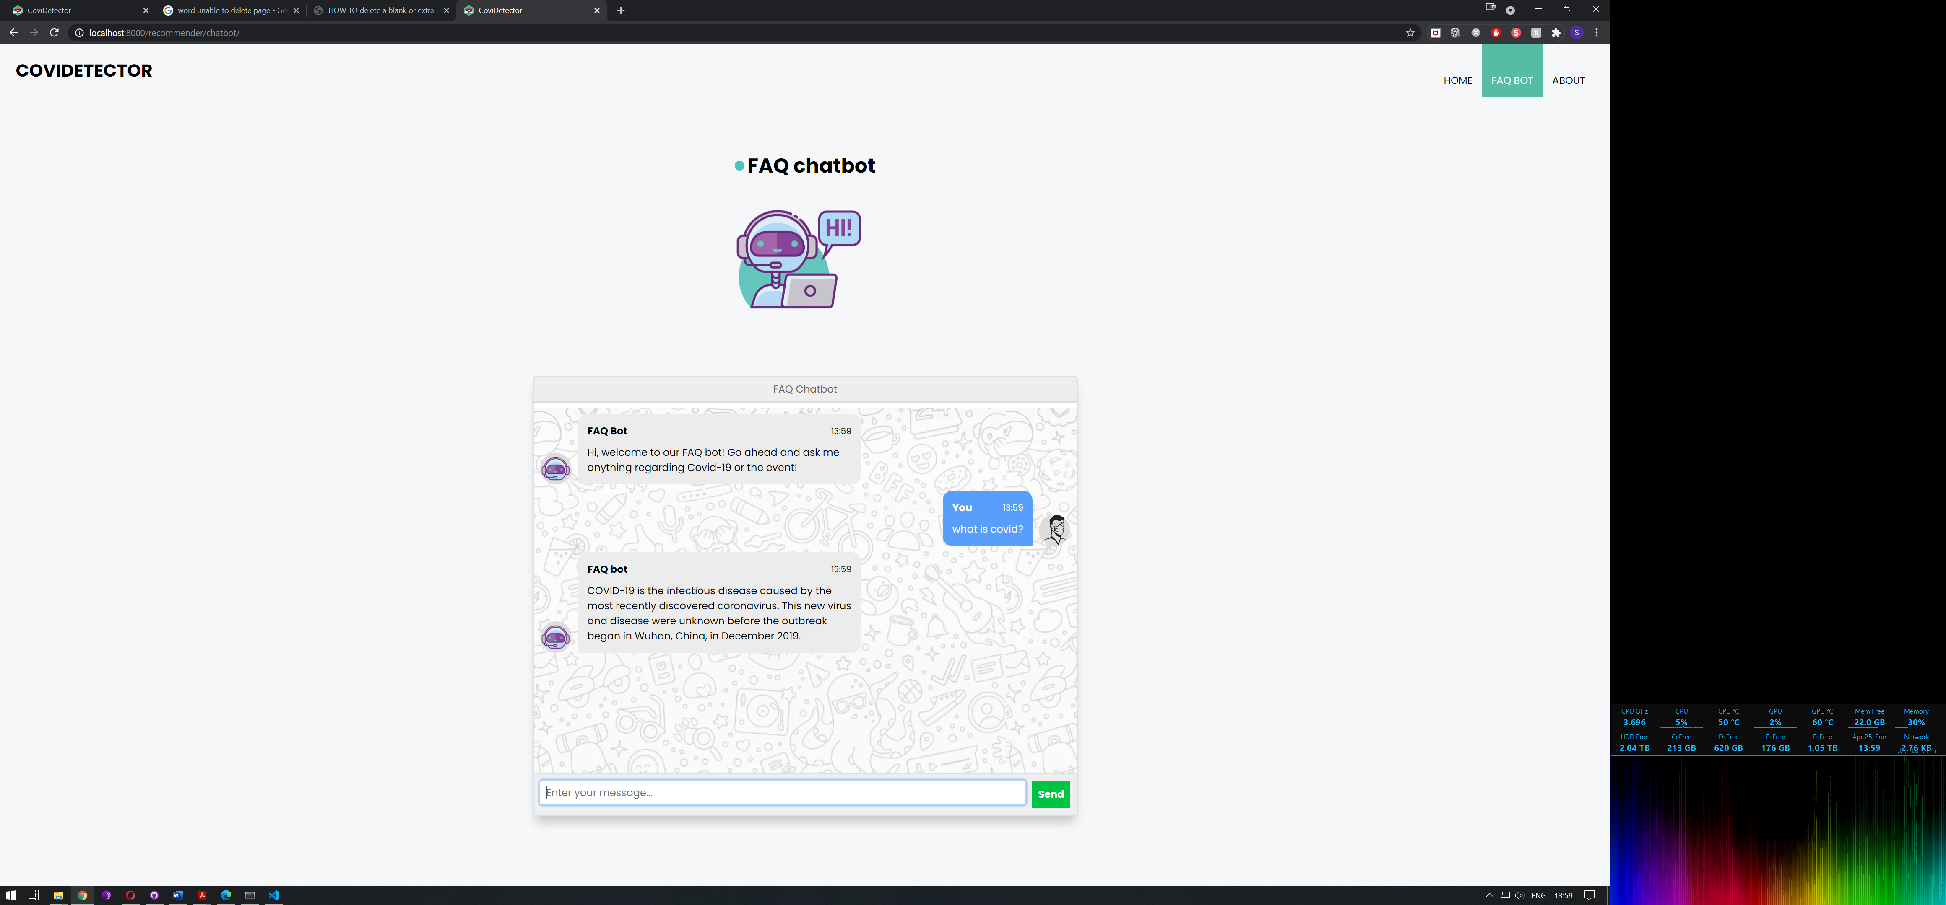

*Image 4: Chatbot replying to covid related questions*

As our solution is dynamic we are able to change the events content to suit each individual event. For demonstration purposes, we are using a Westlife concert as an example.

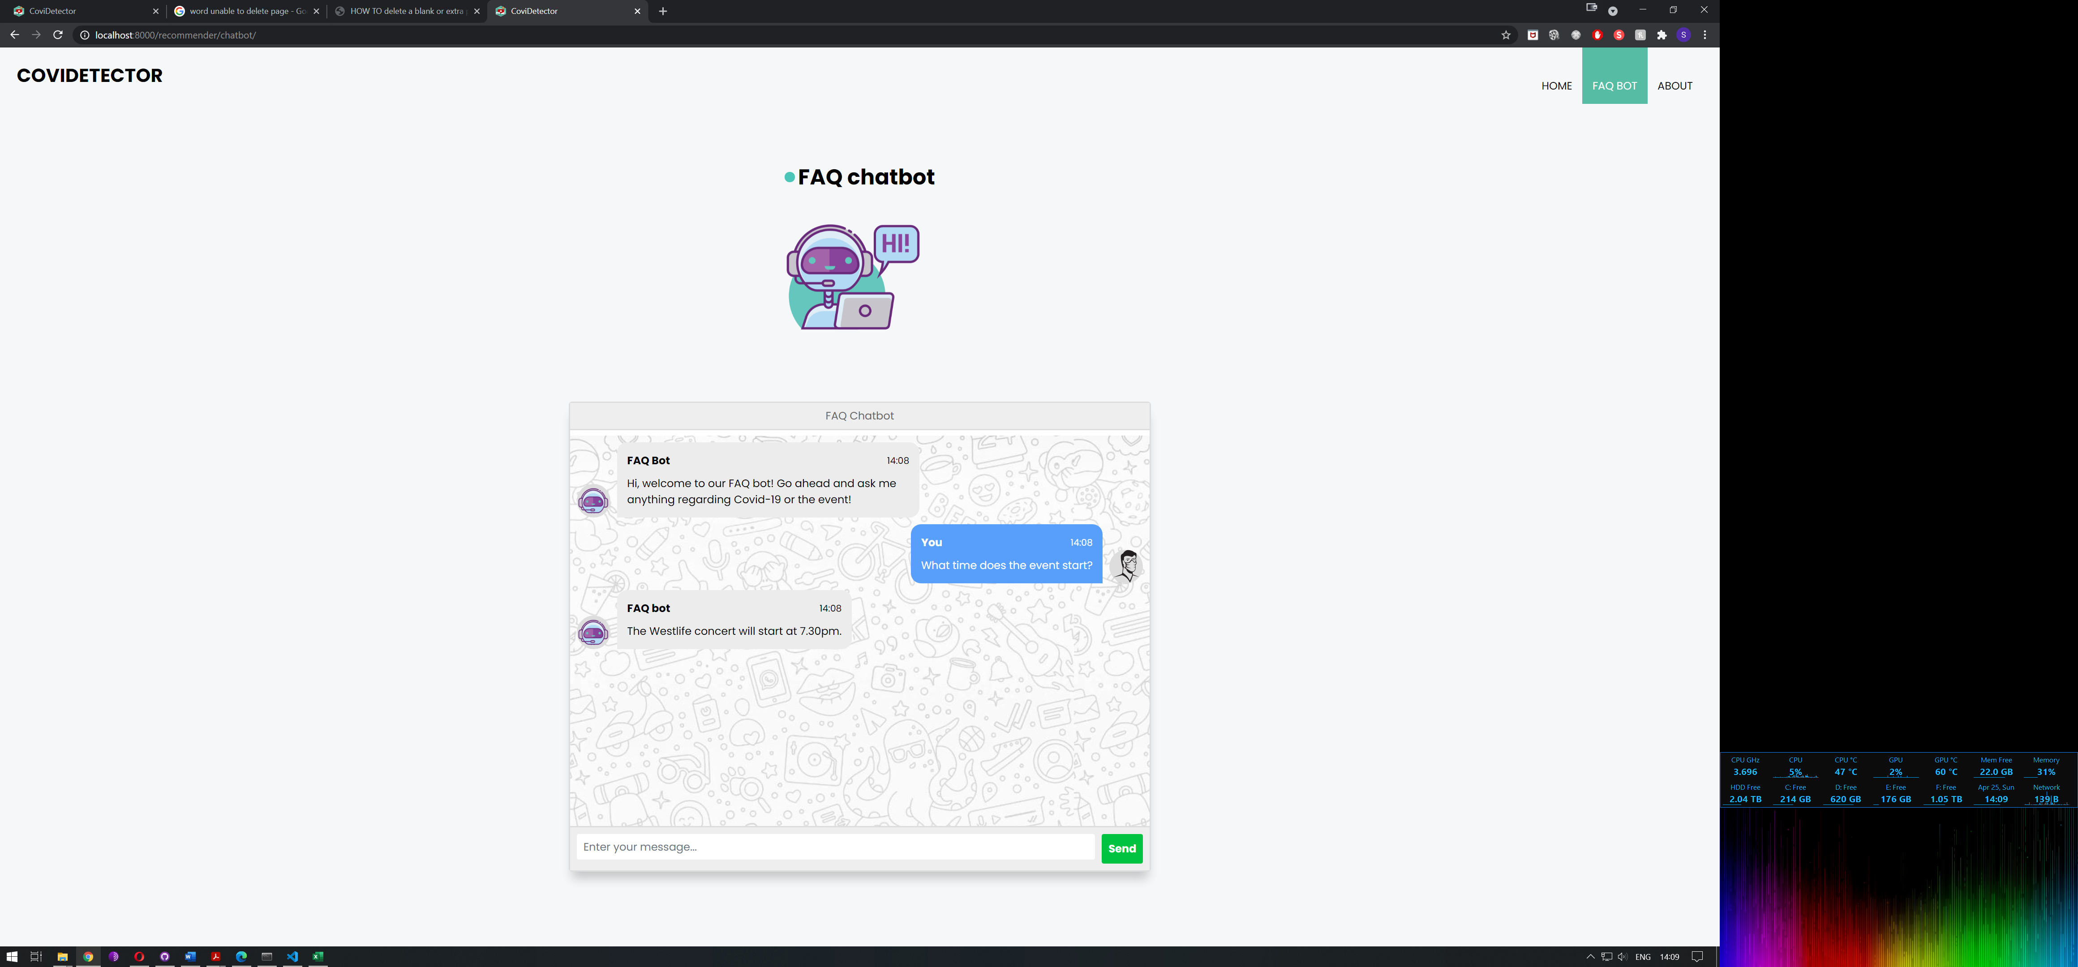

*Image 5: Chatbot replying to events questions*